## **Chapter 1**

## **INTRODUCTION**

In today's fast-paced and information-rich world, the need for accessible, high-quality education is more pressing than ever. With the advent of technology, e-learning platforms have become a cornerstone of modern education, enabling learners to access a vast array of resources from the comfort of their homes. EduSphere is an innovative e-learning platform designed to aggregate educational content from various sources, providing users with a centralized hub for learning and development.

EduSphere leverages the power of Angular for its frontend, ensuring a responsive and user-friendly interface, and Node.js for its backend, providing robust data handling and processing capabilities. This project aims to simplify the learning process by offering a seamless user experience, where learners can easily browse courses, track their progress, and access high-quality educational content.

The primary motivation behind EduSphere is to create a platform that caters to the diverse needs of learners, from beginners to advanced users, across various fields such as coding, personal development, finance, and marketing. By integrating with external educational providers like freeCodeCamp, EduSphere ensures that users have access to the best resources available. This report details the design, implementation, and testing phases of the project, highlighting the challenges faced and the solutions implemented.

**Project Overview**

**Project Description**

EduSphere is an e-learning platform designed to provide users with access to a variety of educational resources. The platform aggregates content from reputable sources, such as freeCodeCamp, and organizes it into easily navigable categories. Users can create accounts, browse available courses, track their learning progress, and access personalized recommendations based on their interests and previous activities.

**Objectives**

* To develop a user-friendly and responsive e-learning platform using Angular for the frontend.
* To implement a robust backend using Node.js to handle data processing, user authentication, and course management.
* To integrate with external educational content providers, offering users a diverse range of courses.
* To provide features that allow users to track their progress and receive personalized course recommendations.
* To ensure a seamless user experience through effective routing, state management, and UI design.

**Scope**

The scope of EduSphere includes the development of the following features:

1. **User Authentication**: Allowing users to register, log in, and manage their profiles.
2. **Course Management**: Displaying a list of available courses, organized into relevant categories.
3. **Progress Tracking**: Enabling users to track their progress through various courses.
4. **Content Integration**: Aggregating educational content from external sources like freeCodeCamp.
5. **Responsive Design**: Ensuring the platform is accessible on various devices, including desktops, tablets, and smartphones.
6. **Admin Dashboard**: Providing administrative functionalities for managing courses and user data.

**Technology Stack**

* **Frontend**: Angular, Bootstrap, HTML, CSS
* **Backend**: Node.js, Express.js
* **Database**: MongoDB
* **Version Control**: Git
* **Deployment**: TBD (e.g., AWS, Heroku)

**Project Phases**

1. **Planning and Requirement Analysis**: Identifying the needs of potential users, defining project requirements, and setting objectives.
2. **Design**: Creating wireframes, UI mockups, and system architecture diagrams.
3. **Implementation**: Developing the frontend and backend components, integrating with external content providers, and setting up the database.
4. **Testing**: Conducting unit, integration, and end-to-end testing to ensure the platform's functionality and reliability.
5. **Deployment**: Deploying the platform to a web server and making it accessible to users.
6. **Maintenance and Future Enhancements**: Continuously improving the platform based on user feedback and adding new features as needed.

By following this structured approach, EduSphere aims to deliver a comprehensive and effective e-learning platform that meets the needs of modern learners.

## **Chapter 2**

## **Objectives**

•**Develop a User-Friendly and Responsive Platform:**

* Utilize Angular for the frontend to ensure a seamless and intuitive user experience across various devices.

• **Implement a Robust Backend:**

* Use Node.js for data handling, user authentication, and course management to provide a solid backend infrastructure.

• **Integrate External Educational Content Providers:**

* Incorporate content from reputable sources such as freeCodeCamp to offer a diverse range of courses.

• **Provide Progress Tracking Features:**

* Enable users to mark courses as started, in-progress, or completed, and display this progress in their profiles.

• **Offer Personalized Course Recommendations:**

* Utilize user data to suggest courses that align with their interests and past activities, enhancing the learning experience.

• **Ensure Seamless User Experience:**

* Implement effective routing, state management, and UI design to facilitate easy navigation and interaction.

## **Chapter 3**

## **SOFTWARE REQUIREMENT SPECIFICATION**

**Functional Requirements**

1. **User Registration and Authentication**:
   * Users should be able to create an account using their email address.
   * Users should be able to log in and log out securely.
   * Password recovery options should be available.
2. **User Profile Management**:
   * Users should be able to view and edit their profile information.
   * Users should be able to track their learning progress.
3. **Course Management**:
   * The platform should display a list of available courses, categorized by subject.
   * Users should be able to search for courses.
   * Detailed course information should be available, including descriptions, modules, and progress tracking.
4. **Content Integration**:
   * The platform should aggregate and display educational content from freeCodeCamp.
   * Users should be able to watch videos and access materials directly from the platform.
5. **Progress Tracking**:
   * Users should be able to mark courses as started, in-progress, and completed.
   * The platform should track users' progress and display it in their profile.
6. **Admin Dashboard**:
   * Admins should be able to manage courses, including adding, editing, and deleting courses.
   * Admins should have access to user data for management purposes.

**Non-Functional Requirements**

1. **Performance**:
   * The platform should load quickly and handle a large number of concurrent users.
   * Content should be efficiently fetched and displayed.
2. **Usability**:
   * The UI should be intuitive and user-friendly.
   * The platform should be accessible on various devices (desktops, tablets, smartphones).
3. **Security**:
   * User data should be securely stored and transmitted.
   * Implement proper authentication and authorization mechanisms.
4. **Scalability**:
   * The system should be scalable to handle an increasing number of users and content.
5. **Reliability**:
   * The platform should be reliable with minimal downtime.
   * Implement proper error handling and recovery mechanisms.

## **Chapter 4**

# **Frontend**

**Technologies Used**

* **Framework**: Angular
* **Styling**: Bootstrap, custom CSS
* **Routing**: Angular Router
* **State Management**: Angular services

**Implementation Steps**

1. **Setup**:
   * Initialize Angular project using Angular CLI.
   * Install necessary dependencies such as Bootstrap and Angular Router.
2. **Component Structure**:
   * **Home Component**: Displays featured courses and platform introduction.
   * **About Component**: Provides information about the platform.
   * **Courses Component**: Lists all available courses fetched from the backend.
   * **Course Details Component**: Shows detailed information about a selected course.
   * **Register Component**: Contains a form for user registration.
   * **Login Component**: Contains a form for user login.
   * **Profile Component**: Displays user profile information and learning progress.
   * **Admin Dashboard**: Allows admins to manage courses and users.
3. **Routing**:
   * Configure routes in app-routing.module.ts.
   * Protect routes such as the profile and admin dashboard using route guards.
4. **State Management**:
   * Use Angular services to manage state, such as user authentication and course data fetching.
5. **UI/UX Design**:
   * Implement responsive design using Bootstrap.

Add custom CSS for additional styling and animations.

**Chapter 5**

## **Backend**

**Technologies Used**

* **Framework**: Spring Boot
* **Database**: MySQL
* **ORM**: Hibernate

**Implementation Steps**

1. **Setup**:
   * Initialize a Spring Boot project.
   * Configure MySQL as the database.
   * Add necessary dependencies for Spring Data JPA and Hibernate.
2. **Database Schema**:
   * **User**:
     + id (Long)
     + username (String)
     + email (String)
     + password (String, hashed)
     + progress (List of Course Progress)
   * **Course**:
     + id (Long)
     + title (String)
     + description (String)
     + category (String)
     + content (List of Modules)
3. **Repositories**:
   * Create Spring Data JPA repositories for User and Course entities.
4. **Services**:
   * Implement services for handling business logic, such as user registration, authentication, course management, and progress tracking.
5. **Controllers**:
   * Create RESTful controllers to expose APIs for frontend interaction.
6. **Security**:
   * Implement JWT for user authentication.
   * Use Spring Security to secure endpoints.

**Frontend-Backend Interaction**

1. **API Consumption**:
   * Use Angular services to make HTTP requests to the Spring Boot backend.
   * Handle responses and update the UI accordingly.
2. **Authentication**:
   * Implement JWT-based authentication.
   * Store JWT token in local storage and include it in HTTP headers for authenticated requests.
3. **Data Binding**:
   * Bind data fetched from the backend to Angular components.
   * Implement form validation and error handling.

**Chapter 6**

**Snapshots**

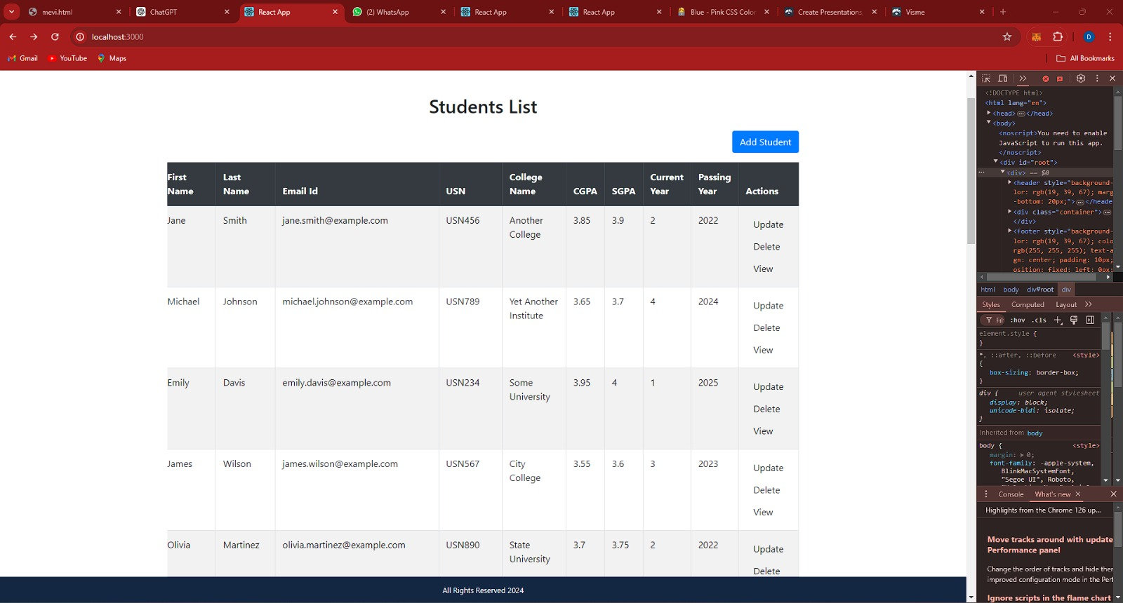

Fig: Students List

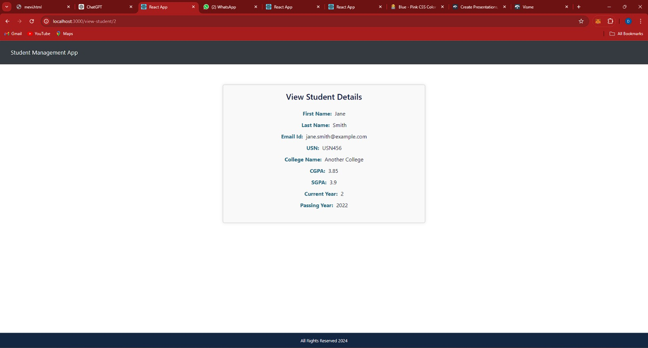

Fig: Student Details

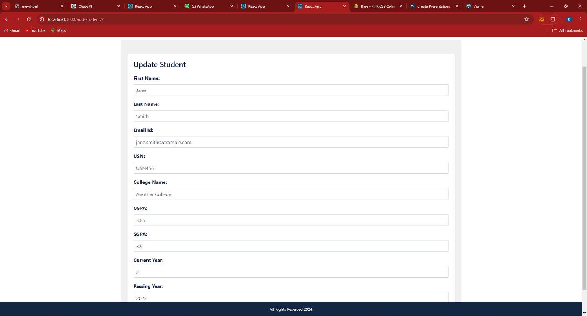

Fig: update student Details

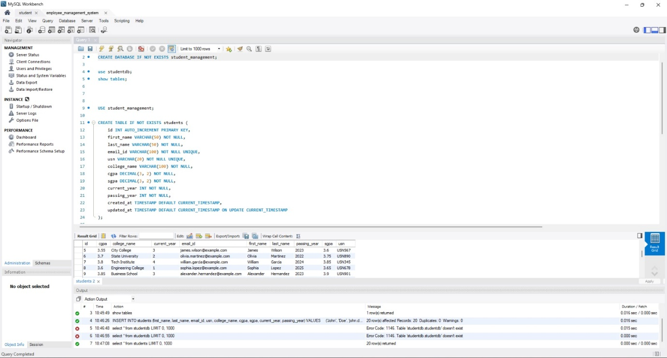

Fig: Data Base

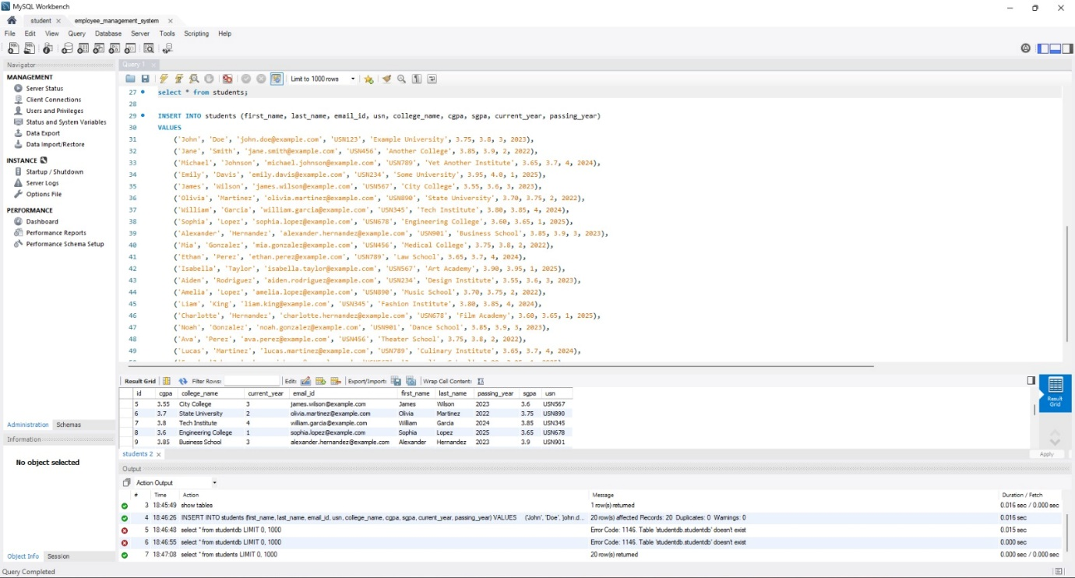

Fig: Back-end Data

## **CONCLUSION**

EduSphere revolutionizes e-learning with its user-friendly platform built using Angular for the frontend and Node.js for the backend, ensuring a responsive and robust learning environment. Integrating content from providers like freeCodeCamp, it offers diverse, high-quality resources for various learning needs.

Key features include user authentication, course management, progress tracking, and an admin dashboard, creating a comprehensive and accessible educational tool. EduSphere is scalable, secure, and designed for accessibility across devices, enhancing online learning's convenience and flexibility.

Overcoming development challenges with innovative solutions, EduSphere is committed to ongoing improvements driven by user feedback and technological advancements. This platform is set to significantly impact education, providing a centralized hub for learners to expand their knowledge and skills.

## **REFERENCES**

* **Angular Documentation:** Agular’s official documentation provides comprehensive guides and tutorials for building web applications using Angular. Available at: https://angular.io/docs
* **Node.js Documentation:** The Node.js official documentation offers detailed information on using Node.js for backend development. Available at: https://nodejs.org/en/docs/
* **MongoDB Documentation:** MongoDB's official documentation includes tutorials and reference materials for using MongoDB as a database solution. Available at: https://docs.mongodb.com/
* **freeCodeCamp:** An open-source platform providing a wide range of coding tutorials and educational content. Available at: https://www.freecodecamp.org/
* **Bootstrap Documentation:** The official Bootstrap documentation offers resources for using Bootstrap to create responsive web designs. Available at: https://getbootstrap.com/docs/
* **Spring Boot Documentation:** The Spring Boot documentation provides in-depth guides for developing applications using Spring Boot. Available at: https://docs.spring.io/spring-boot/docs/current/reference/htmlsingle/
* **JWT (JSON Web Token) Introduction**: Understanding JWT for implementing secure authentication in web applications. Available at: https://jwt.io/introduction/
* **Express.js Documentation:** Official documentation for Express.js, a web application framework for Node.js. Available at: https://expressjs.com/en/starter/installing.html
* **Git Documentation:** Git's official documentation provides detailed guides on using Git for version control. Available at: https://git-scm.com/doc
* **AWS Documentation:** Amazon Web Services documentation offers resources for deploying applications on AWS. Available at: https://docs.aws.amazon.com/
* **Heroku Documentation:** Heroku's official documentation provides guidelines for deploying web applications on the Heroku platform. Available at: https://devcenter.heroku.com/categories/reference
* **Angular CLI:** Official Angular Command Line Interface documentation. Available at: https://angular.io/cli